**CougSat1 Rough Assembly Process (As of 9.10.18)**

This document describes the rough assembly of CougSat1

The 4 primary structural parts look like this, and are fitted as seen below:

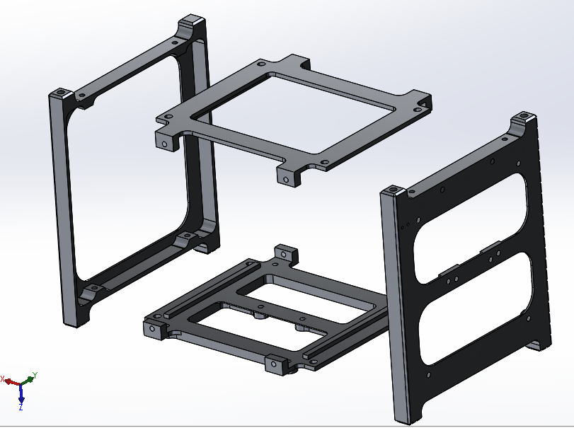

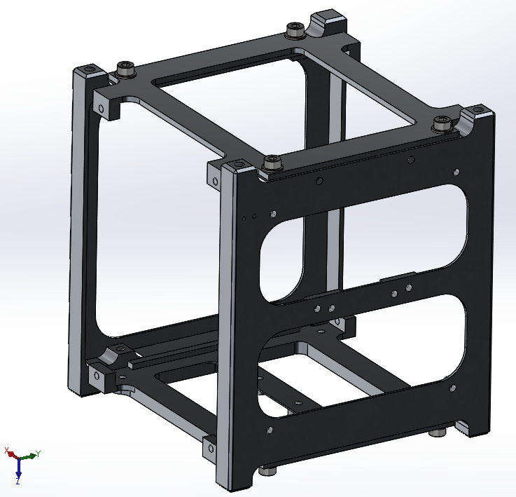

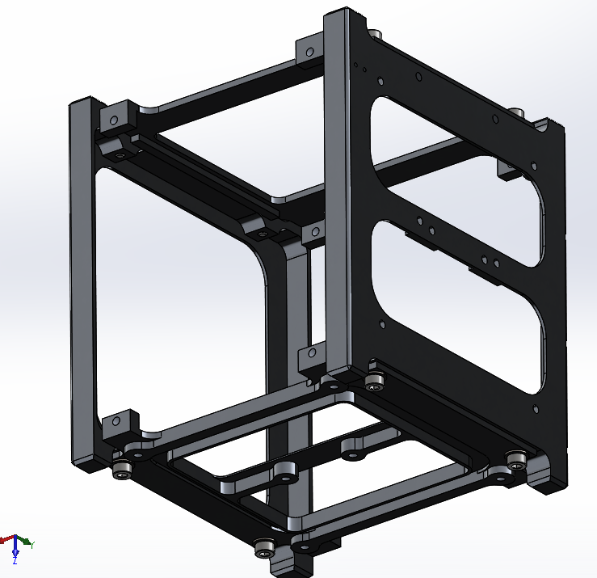

Fitting will be done before the final assembly process. This will attach all major parts to ensure they fit, including the board and backplane, as well as the sideplates of the structure. We will ensure the boards are not being overly stressed and that the overall dimensions of the assembled structure are within the allowed volume limits. This does not need to be done in a cleanroom.

ASSEMBLY:

1. The structure will be set up as followed (the side plates, frontplane (left) and top/bottom should not have been moved since last disassembly). Only the backplane should be missing from the structural parts.

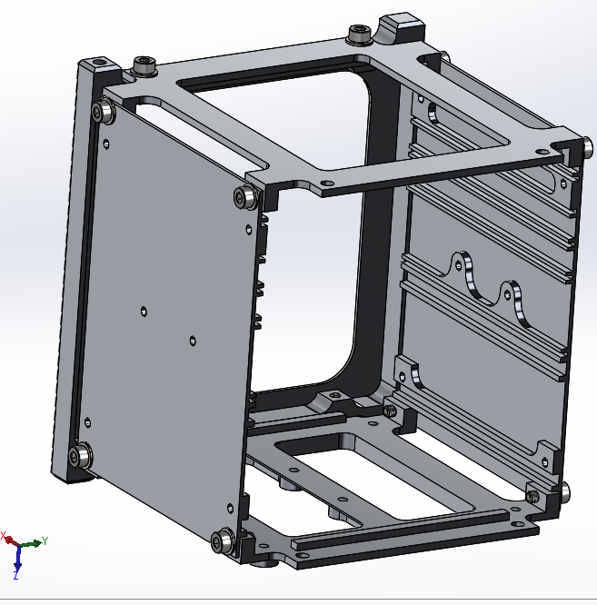

1. Then the backboard will have the backplane attached to it as such:

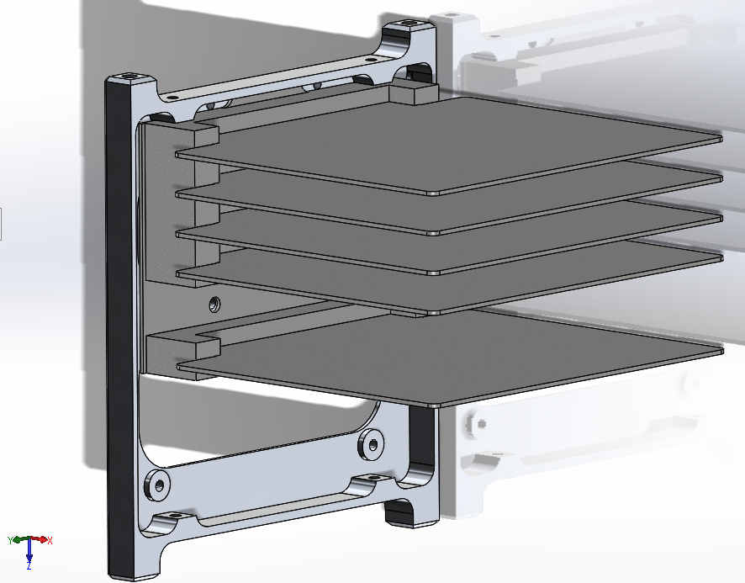

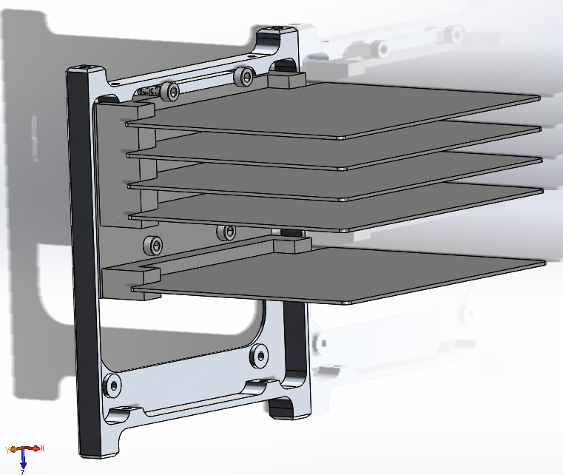

1. And the separation spring/deployment switch will be attached (may be before step 2)

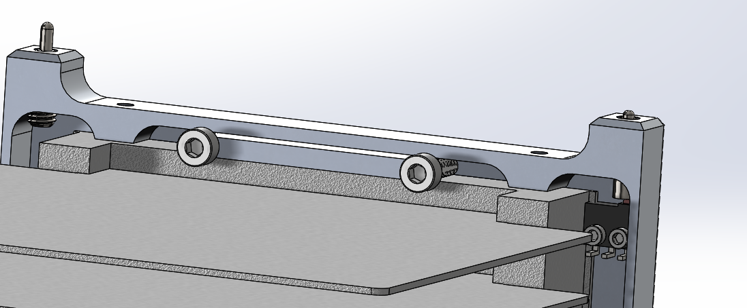

1. This backplate will be inserted into the structure with the boards sliding into the slots:

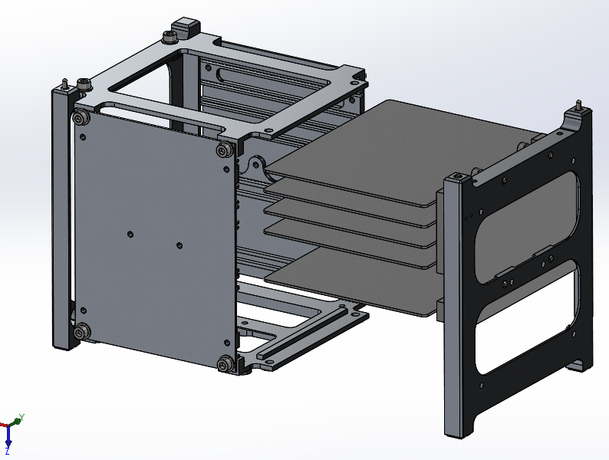

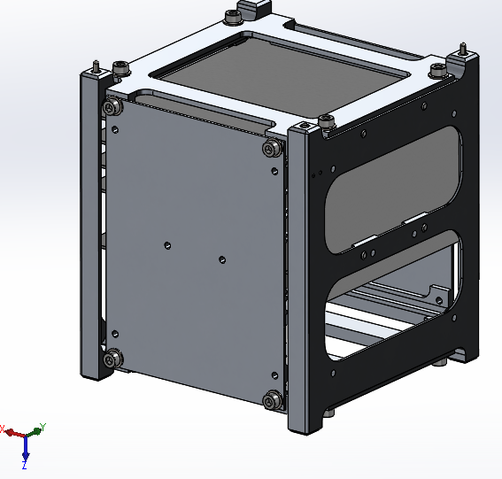

1. The magnetorquers and standoffs for the solar arrays will be installed, one by one:

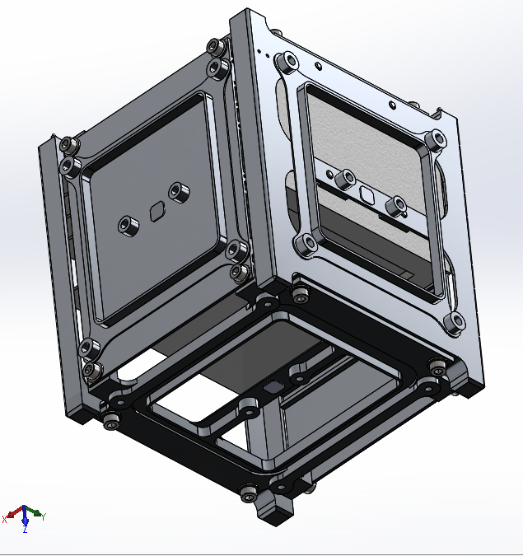

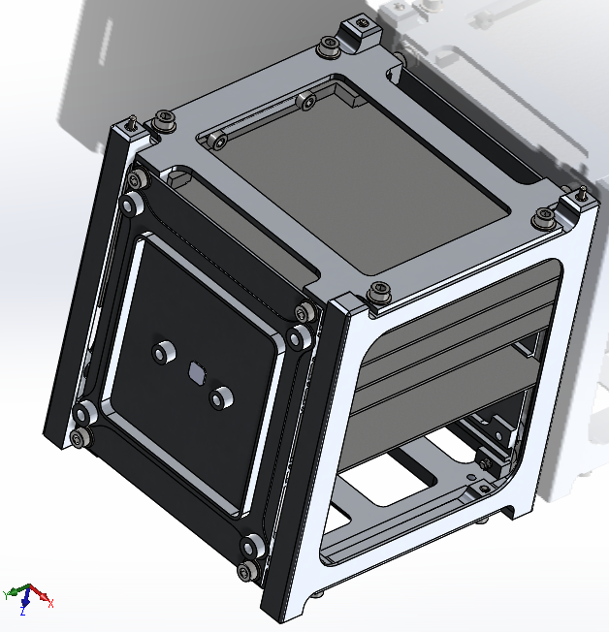

1. Finally, the solar arrays will be attached:

